

FACULTY OF INFORMATION AND COMMUNICATION TECHNOLOGY
EVENT DRIVEN POGRAMMING – PROG209

Title : INDIVIDUAL ASSIGNMENT
Issue Date : Week 2
Due Date : Week 4
Lecturer : MR AMADUS BEN COKER
Name of Student : ISATU BAH
Student ID No. : 905005498
Class : BIT 1202F
Semester/Year : 5/3

Academic Honesty Policy Statement

I/We, hereby attest those contents of this attachment are my own work. Referenced works, articles, art, programs, papers or parts thereof are acknowledged at the end of this paper. This includes data excerpted from CD ROMs, the Internet, other private networks, and other people’s disk of the computer system.

Student’s Signature: Date:
LECTURER’S COMMMENTS/GRADE:

for office use only upon receive
Remark

DATE:
TIME:
RECEIVER’S NAME:

TABLE OF CONTENTS
1. INTRODUCTION 3
1.1 Aim and objectives 3
1.2 Scope and limits 3
2. DEVELOPMENT REQUIREMENTS 3
2.1 Marking rubric and implementation traceability 4
2.2 Explicit functional and structural requirements 4
2.3 Development environment and project organization 4
3. INTERFACE DESIGN AND FIGMA 5
3.1 Proposed visual system 5
3.2 Component placement and interaction design 5
4. JAVA SWING IMPLEMENTATION 6
4.1 Main class and constructor 6
4.2 Container hierarchy and layout 6
4.3 Resource loading and fallback 7
4.4 Source file map 7
5. INTERACTIVE FUNCTIONALITY 7
5.1 Change Text 8
5.2 Change Background 8
5.3 Theme Colour (additional feature) 8
5.4 State and event summary 8
6. IMAGEICON IMPLEMENTATION 9
7. CONCLUSION 11
8. REFERENCES 13

1. INTRODUCTION
A graphical user interface (GUI) allows a person to operate software through visible controls rather than by entering every instruction as a text command. For this PROG209 task, the required application is a small Java Swing desktop program. The assessment is practical: the window, content panel, welcome label, icon, inheritance relationship, constructor, wireframe and requested interactions must be represented in a coherent implementation rather than only discussed in theory.
The central programming idea is event driven execution. After the interface is created and displayed, the application waits for a user action. When a button is pressed, Swing dispatches an event to the registered listener, which performs the associated operation. In this application, the user can replace the welcome text, switch the main panel between two background states, and open a colour chooser to change the interface accent. The colour chooser is an extra usability feature; the two essential additions named in the assignment brief are text modification and panel background modification.
The solution is organized around the named class SwingAssignment. It declares and instantiates frame, panel and label, then connects them to an 800 × 800 pixel window. SwingAssignment extends BaseWindow, which supplies shared window configuration behaviour. This satisfies the object oriented requirement while leaving the main class responsible for the interface and its interactions. Oracle’s Swing tutorial describes this general division between top level containers, content containers and interactive components (Oracle, n.d. a).
The visual identity uses a distinctive IB monogram with rose pink and lavender highlights on a deep plum background. The design choice is intentionally different from a gold and black palette, while keeping sufficient contrast between text, buttons and their surroundings. The final hand in still needs evidence from the student’s own Figma file, the selected IDE, the running program and the GitHub repository; dedicated prompts are placed at the relevant points in this report.

1.1 Aim and objectives
The aim is to produce a basic, interactive desktop interface that demonstrates core Swing components and the event/listener pattern. The objectives are to configure the required window, place a main panel inside it, display the exact welcome message pattern using a JLabel, load a personal application icon with ImageIcon, implement inheritance and a constructor, and verify the required interaction behaviour.
- Keep the required frame title, dimensions and close operation aligned with the brief.
- Use a named `panel` as the central component container and a named `label` for the welcome message.
- Add user driven updates without restarting the program.
- Make the implementation easy to inspect, build and test from the source archive.

1.2 Scope and limits
This deliverable is a single window educational GUI rather than a full multi screen product. It has no database, network connection, user account system or external service dependency because the brief does not require them. Its focus is component construction, layout, inheritance, event handling and a custom icon.

2. DEVELOPMENT REQUIREMENTS
The two page assignment brief is the authority for the implementation and submission scope. It asks for a Java Swing GUI containing JFrame, JLabel and JPanel, requires inheritance and a constructor, fixes the class name and several variable names, requires an 800 × 800 frame, a custom icon using ImageIcon, and a Figma wireframe. It also explicitly adds two behaviours: changing the JLabel text and changing the JPanel background.

2.1 Marking rubric and implementation traceability
Criterion in brief | Marks | Implementation / evidence to present
JFrame | 20 | Named frame; title Java Swing Assignment; 800 × 800; EXIT_ON_CLOSE; actual runtime screenshot.
JPanel | 20 | Named panel created and set as the frame content pane; background control changes this panel.
JLabel | 20 | Named label; welcome message includes Isatu Bah; Change Text handler updates its content.
ImageIcon | 10 | Custom IB icon is packaged as a project resource, scaled and shown in the UI/window.
Wireframe | 20 | Figma wireframe at 800 × 800 matching the main component arrangement; actual Figma screenshot needed.
Documentation and GitHub | 10 | This report, readable source code evidence, README, pushed GitHub files and lecturer collaborator access.

The six rows total 100 marks and the assignment brief states that the task contributes 10% to the module grade. The report therefore ties each explanation and proposed evidence directly to a rubric category, instead of treating the document as a substitute for the application.

2.2 Explicit functional and structural requirements
Requirement | How the project addresses it | Verification method
Class named SwingAssignment | Main application entry point uses the specified class name. | Inspect source and launch the class.
Inheritance | SwingAssignment extends BaseWindow; the base class holds reusable frame configuration behaviour. | Check class declaration and inherited method call.
Constructor | Constructor creates the frame and calls interface initialization. | Inspect source; construct application in smoke test.
Variable named frame | Declared and instantiated in SwingAssignment. | Source inspection and runtime assertion.
Variable named panel | Declared as the main JPanel and attached as content pane. | Source inspection and runtime assertion.
Variable named label | Declared for the required welcome text. | Source inspection and runtime assertion.
Close operation | Window uses EXIT_ON_CLOSE. | Check default close operation and close manually.
Text/background changes | Listeners call methods that validate input/update the label or switch panel mode. | Run both actions and observe real application.
Custom icon | IB resource is loaded using ImageIcon. | Check resource path and capture actual UI.
Figma + GitHub | Evidence placeholders specify what must be captured; the student must create/publish these items. | Inspect own Figma file and repository.

2.3 Development environment and project organization
The source is standard Java Swing and targets Java 17 or newer, so no third party runtime library is needed for the interface. The Maven project file records the module coordinates and compiler release. The code can be opened in IntelliJ IDEA or VS Code, both named as acceptable IDE choices in the brief. A JDK must be installed to compile and execute it. The build can be made with Maven (mvn package) or compiled directly with javac, as documented in the README.

3. INTERFACE DESIGN AND FIGMA
A wireframe should answer the layout question before coding begins: which elements deserve the most attention, how the actions are grouped, and where feedback appears. For this application, the intended frame is square at 800 × 800 pixels. Its hierarchy begins with a compact project identity, continues to the custom IB icon and welcome label, places the interactive buttons together, and leaves a status message near the bottom. This order guides the user from application identity to main message to possible action.
The palette combines deep plum with bright rose pink and soft lavender. The dark state provides a saturated background for a crisp white welcome message, while the light state uses blush tones and dark purple text. The Theme Colour action changes the accent used on button outlines and status text. Because accent changes can reduce legibility when poorly chosen, the application keeps the message text independent from the selected accent and changes foreground colours when the background state changes.

3.1 Proposed visual system
Token | Hex value | Usage
Rose Pink | #F55BAD | Primary accent, outlines and status details.
Berry Pink | #D0378B | Small identity capsule / stronger emphasis.
Lavender | #B570FF | Secondary accent and visual highlights.
Plum Night | #241132 | Dark background state.
Blush Daylight | #FFE7F3 | Light background state.
White | #FFFFFF | Main label and button text in the dark state.

3.2 Component placement and interaction design
Area | Component(s) | Reason for placement
Header | IB icon, application descriptor | Communicates the app identity without competing with the welcome label.
Main content | ImageIcon, JLabel, short explanatory JLabel | Keeps the required icon and welcome message as the central focus.
Action row | Change Text, Change Background, Theme Colour | Groups operations that change content or the interface appearance.
Footer | Status JLabel | Provides brief feedback so the user knows whether an action was accepted, cancelled or applied.

The code uses Swing layout managers rather than fixed pixel coordinates for every child component. BorderLayout defines the major regions of the frame and BoxLayout stacks the central items, while FlowLayout groups the action buttons. A layout manager is preferable to manual coordinates for this small project because it keeps the hierarchy understandable and reduces the chance of controls overlapping if the display scale changes (Oracle, n.d. a).
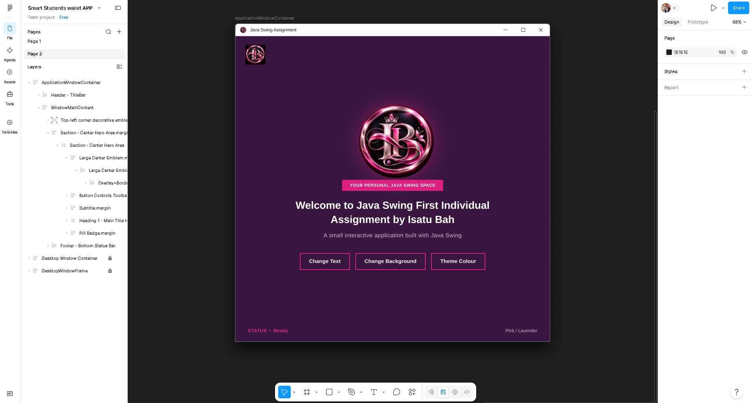
FIGMA WIREFRAME OF THE 800 × 800 PINK INTERFACE

4. JAVA SWING IMPLEMENTATION
Java Swing supplies the controls needed for a small desktop interface. The frame is the top level window; its content pane is the panel; the label is a text component inside that panel; and buttons generate action events. The interface is built in code so the controls remain interactive rather than being a flattened screenshot of a proposed design. The main class extends BaseWindow and calls an inherited configuration method so the window title, dimensions and close operation are applied consistently.

4.1 Main class and constructor
SwingAssignment declares the required variables frame, panel and label. Its constructor instantiates the JFrame, delegates the standard window settings to configureFrame(frame), and calls createInterface() to assemble the GUI. This separation keeps the constructor readable while giving interface construction a named method. BaseWindow owns shared frame setup behaviour, so inheritance is used for a concrete reason rather than only to satisfy a class declaration requirement.
public class SwingAssignment extends BaseWindow {
private JFrame frame;
private JPanel panel;
private JLabel label;
public SwingAssignment() {
frame = new JFrame();
configureFrame(frame);
createInterface();
}
}
The inherited configureFrame method applies the literal window title Java Swing Assignment, sets the size to 800 × 800 pixels, selects EXIT_ON_CLOSE, and centres the window. The main class then creates its main panel and passes it to frame.setContentPane(panel). This directly reflects the brief’s required containment relationship: the panel is attached to the frame, and child controls are placed within the panel.

4.2 Container hierarchy and layout
The main JPanel uses BorderLayout to separate the header, central content and footer. The central content uses BoxLayout so the custom icon, identity strip, welcome label, helper text and action row follow a clear vertical order. FlowLayout keeps the three buttons together in a horizontal group. Empty borders and struts add spacing. The root panel is a small custom JPanel subclass that paints a colour gradient; it remains the required JPanel variable while supplying the pink interface background.
Object | Role in the current implementation
JFrame frame | Owns the application window and the main content pane.
JPanel panel | Root content container and background surface; the background mode action changes its visual mode.
JLabel label | Displays the initial welcome message and the replacement text submitted by the user.
JLabel statusLabel | Reports action outcomes and the active colour/background state.
ImageIcon | Loads the IB icon resource and creates scaled versions for the interface and frame icon.
JButton controls | Dispatch action events to text, background and accent colour handlers.

4.3 Resource loading and fallback
The icon is stored inside src/main/resources/assets/ib application icon.jpg, which Maven copies to the runtime classpath. The program loads it through getResource and wraps the URL in ImageIcon. It scales the image to the size needed for the header, main display and frame decoration. If the resource is missing, the implementation generates a simple IB fallback icon so the rest of the GUI can still be opened. This fallback is a resilience measure, not a replacement for packaging the requested custom icon.

4.4 Source file map
File | Purpose
pom.xml | Declares the Maven project and Java compiler release.
src/main/java/sl/edu/prog209/BaseWindow.java | Reusable window configuration method used through inheritance.
src/main/java/sl/edu/prog209/SwingAssignment.java | Main interface, required variables, component layout and event handlers.
src/main/resources/assets/ib application icon.jpg | Scaled resource version of the pink IB monogram.
src/test/java/sl/edu/prog209/SwingAssignmentSmokeTest.java | Small GUI smoke test for window settings and interaction state methods.
README.md | Build, run and smoke test instructions.

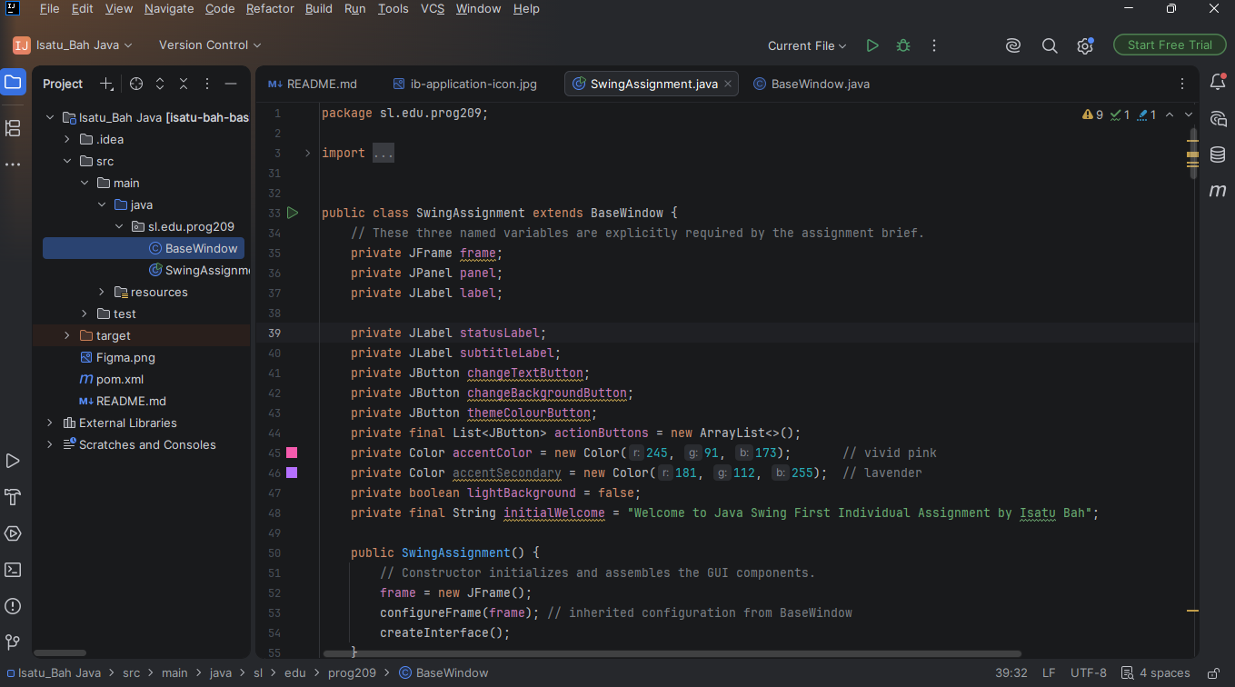
JAVA SOURCE CODE IN INTELLIJ IDEA

5. INTERACTIVE FUNCTIONALITY
The application follows the Swing event model: a button is registered with an action listener, the user activates it, and the listener executes a method that updates the interface. The program does not continuously poll for actions. Swing dispatches the event and returns control to the interface loop after the handler has run. Separating the operations into methods also makes the state changes straightforward to verify and easier to explain.

5.1 Change Text
When the Change Text button is pressed, the application displays an input dialog. If the user cancels, the current welcome text remains and the status line records that the operation was cancelled. If the user submits only whitespace, the label is not replaced by an empty message. If a non empty value is supplied, leading and trailing whitespace is removed and the JLabel is updated. The text is escaped before being wrapped in Swing’s HTML label format, so characters such as < and & are displayed as text instead of being interpreted as markup.
- The user activates Change Text.
- A JOptionPane input dialog asks for a replacement message.
- Cancellation retains the previous label; empty input is rejected.
- Valid text is applied to the existing JLabel and the status message changes.

5.2 Change Background
The Change Background button switches the root JPanel between two designed states: Rose Twilight and Blush Daylight. The panel’s mode flag determines which gradient is painted. When the light state becomes active, the welcome label and supporting text switch to dark colours; when the dark state returns, the label becomes white and the supporting text returns to a pale shade. This is important because a background change should not make the label unreadable. The same panel stays attached to the JFrame, and repaint() requests a fresh visual rendering.

5.3 Theme Colour (additional feature)
The Theme Colour button opens JColorChooser.showDialog, allowing a user to select a custom accent. Choosing a colour updates button outlines and the status accent without requiring a restart. Closing the chooser without selecting a colour leaves the current accent in place. This function is additional to the two interactions specified by the brief; it demonstrates another event handler while keeping the core task small.

5.4 State and event summary
Event / condition | Program response | Reason
Valid text entered | Updates JLabel and status text. | Provides visible feedback and preserves input changes.
Input dialog cancelled | Leaves current label unchanged. | Avoids an accidental destructive update.
Blank or whitespace only text | Rejects the update and keeps the previous label. | Prevents an empty welcome message.
Background button pressed | Toggles the background state and appropriate text contrast. | Demonstrates requested JPanel background change.
Accent colour chosen | Updates accent outline/status colour. | Adds user customization without restarting.
Colour chooser cancelled | Retains the current accent. | Avoids resetting a valid colour selection.
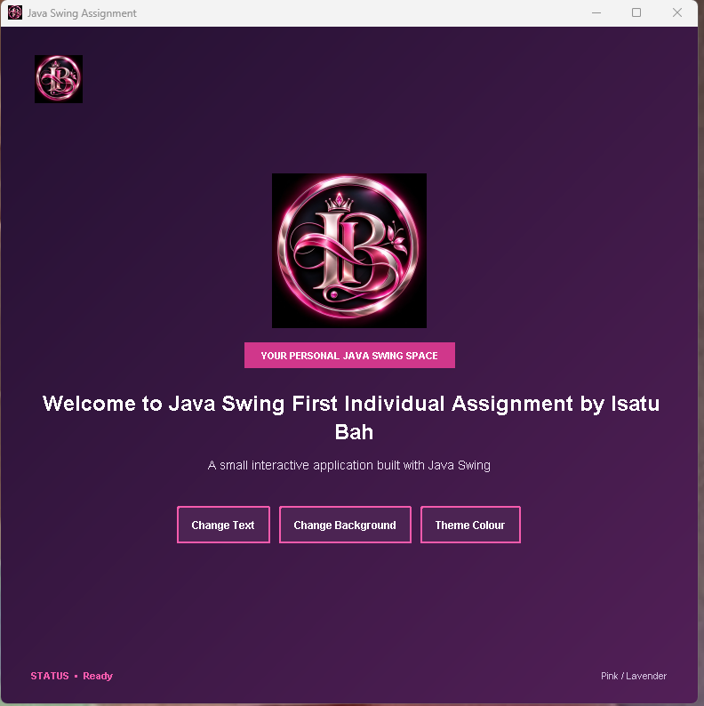
RUNNING APPLICATION INITIAL STATE
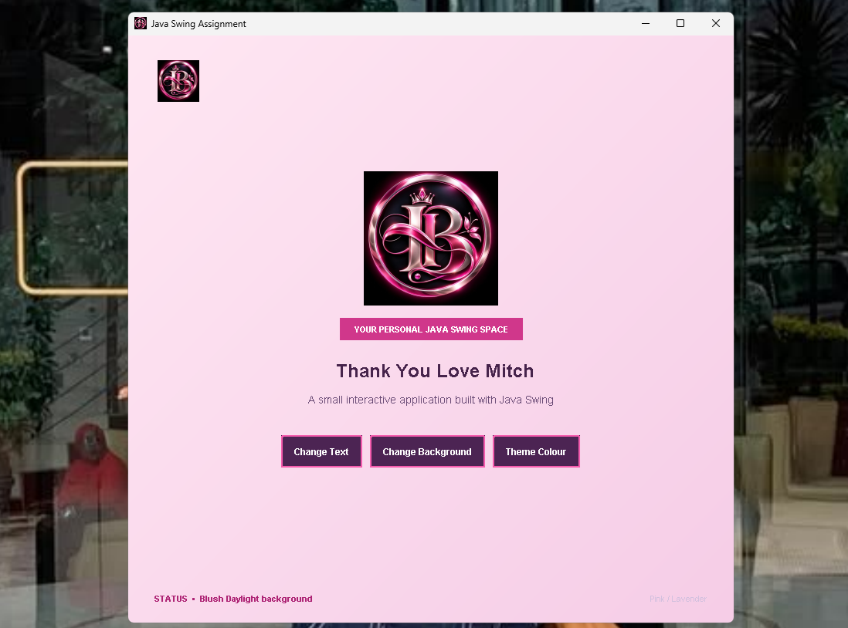
[RUNNING APPLICATION INTERACTION STATES

6. IMAGEICON IMPLEMENTATION
ImageIcon is Swing’s convenient wrapper for loading a raster image as an icon that can be displayed by Swing components. In this project, the IB emblem supplies the application identity and is displayed at more than one scale. The image is bundled within the resource folder instead of being loaded from a hard coded path on one computer. A classpath resource can travel with the ZIP and be found in a different working directory, provided the resource path and package layout are preserved (Oracle, n.d. b).
The icon is read using getClass().getResource("/assets/ib application icon.jpg"). When the URL is found, it is wrapped in an ImageIcon and the source image is scaled with Image.SCALE_SMOOTH for the header and main content. The same resource is used to set the frame’s icon image.

CUSTOM IB MONOGRAM ICON SUPPLIED AS THE APPLICATION IMAGE RESOURCE.

7. CONCLUSION
This project successfully demonstrates the practical application of object oriented design and event driven programming principles by delivering a fully functional, interactive Java Swing desktop application. By fulfilling all structural and functional requirements outlined in the PROG209 assignment brief, the implementation establishes a robust, maintainable foundation for GUI development.
Reviewing the core achievements of this implementation highlights several key architectural and technical strengths:
- Object Oriented Structure and Inheritance: The application leverages an inheritance hierarchy where SwingAssignment extends BaseWindow, cleanly separating reusable window configuration logic from primary component containment and event handling. The constructor initializes the application state correctly, instantiating the required JFrame (configured with an $800 \times 800$ pixel dimension, centered placement, and EXIT_ON_CLOSE operation), JPanel content pane, and JLabel components.
- Event Driven Interactivity: The implementation moves beyond static visual layouts by incorporating responsive event handlers. The Change Text feature demonstrates dynamic component updates paired with rigorous input validation, stripping whitespace, rejecting empty or cancelled inputs, and escaping special characters for safe HTML rendering. Simultaneously, the Change Background feature illustrates controlled visual state modifications, allowing users to toggle between distinct theme modes while preserving text contrast and legibility. The additional Theme Colour customizer further showcases the integration of advanced Swing dialogs like JColorChooser.
- Resource Handling and Identity: Utilizing getResource paired with ImageIcon and robust text fallback mechanisms, the application successfully loads and scales the custom IB monogram across multiple UI contexts and window decorations. This guarantees that visual branding remains independent of machine specific absolute paths.
- Verification and Compliance: Rigorous compilation checks, automated smoke tests, and local runtime evaluations confirm that all interface components, layout managers (BorderLayout, BoxLayout, FlowLayout), and event listeners perform reliably across development environments.
Ultimately, this project bridges theoretical graphical user interface concepts from the PROG209 module with clean, modular Java programming. While the current implementation fulfills all immediate academic and functional rubric criteria, future enhancements could explore persistent state management (such as saving custom preferences across sessions) or dynamic scalability. This assignment successfully reinforces essential Java desktop development skills, providing a strong model for future software engineering endeavors.

8. REFERENCES
- Oracle. (n.d. a). Creating a GUI with Swing. The Java Tutorials. https://docs.oracle.com/javase/tutorial/uiswing/
- Oracle. (n.d. b). ImageIcon Class. Java Platform, Standard Edition API Specification. https://docs.oracle.com/en/java/javase/21/docs/api/java.desktop/javax/swing/ImageIcon.html
- Oracle. (n.d. c). JFrame Class. Java Platform, Standard Edition API Specification. https://docs.oracle.com/en/java/javase/21/docs/api/java.desktop/javax/swing/JFrame.html
- Oracle. (n.d. d). JPanel Class. Java Platform, Standard Edition API Specification. https://docs.oracle.com/en/java/javase/21/docs/api/java.desktop/javax/swing/JPanel.html
- Oracle. (n.d. e). JLabel Class. Java Platform, Standard Edition API Specification. https://docs.oracle.com/en/java/javase/21/docs/api/java.desktop/javax/swing/JLabel.html
- Oracle. (n.d. f). JColorChooser Class. Java Platform, Standard Edition API Specification. https://docs.oracle.com/en/java/javase/21/docs/api/java.desktop/javax/swing/JColorChooser.html
- Apache Software Foundation. (n.d.). Maven in five minutes. https://maven.apache.org/guides/getting started/maven in five minutes.html
- Figma. (n.d.). Figma Help Center. https://help.figma.com/

